Death destroyed
Key Verse:
1 Corinthians 15:20
²⁰ But now Christ has been raised from the dead, the first fruits of those who are asleep.

1. Christ’s Victory Over Death
1 Corinthians 15:20-26

²⁰ But now Christ has been raised from the dead, the first fruits of those who are asleep. ²¹ For since by a man came death, by a man also came the resurrection of the dead. ²² For as in Adam all die, so also in Christ all will be made alive. ²³ But each in his own order: Christ the first fruits, after that those who are Christ's at His coming, ²⁴ then comes the end, when He hands over the kingdom to the God and Father, when He has abolished all rule and all authority and power. ²⁵ For He must reign until He has put all His enemies under His feet. ²⁶ The last enemy that will be abolished is death.

2. Sharing Christ’s Victory
1 Corinthians 15:35-49

³⁵ But someone will say, "How are the dead raised? And with what kind of body do they come?" ³⁶ You fool! That which you sow does not come to life unless it dies; ³⁷ and that which you sow, you do not sow the body which is to be, but a bare grain, perhaps of wheat or of something else. ³⁸ But God gives it a body just as He wished, and to each of the seeds a body of its own. ³⁹ All flesh is not the same flesh, but there is one flesh of men, and another flesh of beasts, and another flesh of birds, and another of fish. ⁴⁰ There are also heavenly bodies and earthly bodies, but the glory of the heavenly is one, and the glory of the earthly is another. ⁴¹ There is one glory of the sun, and another glory of the moon, and another glory of the stars; for star differs from star in glory.
⁴² So also is the resurrection of the dead. It is sown a perishable body, it is raised an imperishable body; ⁴³ it is sown in dishonor, it is raised in glory; it is sown in weakness, it is raised in power; ⁴⁴ it is sown a natural body, it is raised a spiritual body. If there is a natural body, there is also a spiritual body. ⁴⁵ So also it is written, "The first MAN, Adam, BECAME A LIVING SOUL." The last Adam became a life-giving spirit. ⁴⁶ However, the spiritual is not first, but the natural; then the spiritual. ⁴⁷ The first man is from the earth, earthy ; the second man is from heaven. ⁴⁸ As is the earthy, so also are those who are earthy; and as is the heavenly, so also are those who are heavenly. ⁴⁹ Just as we have borne the image of the earthy, we will also bear the image of the heavenly.

3. Triumphant Through Christ’s Victory
1 Corinthians 15:50-57
⁵⁰ Now I say this, brethren, that flesh and blood cannot inherit the kingdom of God; nor does the perishable inherit the imperishable. ⁵¹ Behold, I tell you a mystery; we will not all sleep, but we will all be changed, ⁵² in a moment, in the twinkling of an eye, at the last trumpet; for the trumpet will sound, and the dead will be raised imperishable , and we will be changed. ⁵³ For this perishable must put on the imperishable, and this mortal must put on immortality. ⁵⁴ But when this perishable will have put on the imperishable, and this mortal will have put on immortality, then will come about the saying that is written, "DEATH IS SWALLOWED UP in victory. ⁵⁵ "O DEATH, WHERE IS YOUR VICTORY? O DEATH, WHERE IS YOUR STING?" ⁵⁶ The sting of death is sin, and the power of sin is the law; ⁵⁷ but thanks be to God, who gives us the victory through our Lord Jesus Christ.

GROW DAILY
Death Destroyed
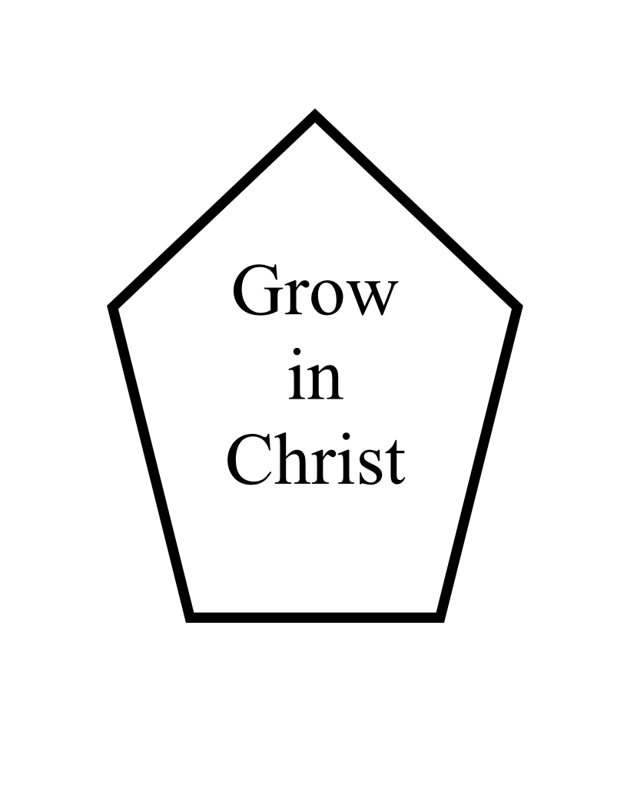
MONDAY:
Hope of the Resurrection
Job 19:23-27
TUESDAY:
Resurrection Foretold
Psalm 16:8-11
WEDNESDAY:
Order of Resurrection
John 5:24-29
THURSDAY:
Promise of Resurrection
John 11:23-26
FRIDAY:
Resurrection of Believers
1 Thessalonians 4:13-18
SATURDAY:
Resurrection of the Dead
Revelation 20:4-6, 11-15

Calvary Mennonite
Mathis, Texas
Sunday School
Adult English Class
Meets Sundays 10:00 A.M.

You’re invited to grow with us!
April 8, 2012

MONDAY:
Hope of the Resurrection
Job 19:23-27
²³ "Oh that my words were written! Oh that they were inscribed in a book! ²⁴ "That with an iron stylus and lead They were engraved in the rock forever! ²⁵ "As for me, I know that my Redeemer lives, And at the last He will take His stand on the earth . ²⁶ "Even after my skin is destroyed,
Yet from my flesh I shall see God; ²⁷ Whom I myself shall behold,
And whom my eyes will see and not another.
My heart faints within me!

TUESDAY:
Resurrection Foretold
Psalm 16:8-11
⁸ I have set the LORD continually before me;
Because He is at my right hand, I will not be shaken. ⁹ Therefore my heart is glad and my glory rejoices;
My flesh also will dwell securely. ¹⁰ For You will not abandon my soul to Sheol ; Nor will You allow Your Holy One to undergo decay. ¹¹ You will make known to me the path of life; In Your presence is fullness of joy; In Your right hand there are pleasures forever.

WEDNESDAY:
Order of Resurrection
John 5:24-29
24 "Truly, truly, I say to you, he who hears My word, and believes Him who sent Me, has eternal life, and does not come into judgment, but has passed out of death into life.
Two Resurrections
25 "Truly, truly, I say to you, an hour is coming and now is, when the dead will hear the voice of the Son of God, and those who hear will live. 26 "For just as the Father has life in Himself, even so He gave to the Son also to have life in Himself; 27 and He gave Him authority to execute judgment, because He is the Son of Man. 28 "Do not marvel at this; for an hour is coming, in which all who are in the tombs will hear His voice, 29 and will come forth; those who did the good deeds to a resurrection of life, those who committed the evil deeds to a resurrection of judgment.

THURSDAY:
Promise of Resurrection
John 11:23-26

²³ and that you be renewed in the spirit of your mind, ²⁴ and put on the new self , which in the likeness of God has been created in righteousness and holiness of the truth. ²⁵ Therefore, laying aside falsehood, SPEAK TRUTH EACH ONE of you WITH HIS NEIGHBOR, for we are members of one another. ²⁶ BE ANGRY, AND yet DO NOT SIN; do not let the sun go down on your anger, ²⁷ and do not give the devil an opportunity. ²⁸ He who steals must steal no longer; but rather he must labor, performing with his own hands what is good, so that he will have something to share with one who has need. ²⁹ Let no unwholesome word proceed from your mouth, but only such a word as is good for edification according to the need of the moment, so that it will give grace to those who hear. ³⁰ Do not grieve the Holy Spirit of God, by whom you were sealed for the day of redemption. ³¹ Let all bitterness and wrath and anger and clamor and slander be put away from you, along with all malice. ³² Be kind to one another, tender-hearted, forgiving each other, just as God in Christ also has forgiven you .
FRIDAY:
Resurrection of Believers
1 Thessalonians 4:13-18
¹³ But we do not want you to be uninformed, brethren, about those who are asleep, so that you will not grieve as do the rest who have no hope. ¹⁴ For if we believe that Jesus died and rose again, even so God will bring with Him those who have fallen asleep in Jesus. ¹⁵ For this we say to you by the word of the Lord, that we who are alive and remain until the coming of the Lord, will not precede those who have fallen asleep. ¹⁶ For the Lord Himself will descend from heaven with a shout , with the voice of the archangel and with the trumpet of God, and the dead in Christ will rise first. ¹⁷ Then we who are alive and remain will be caught up together with them in the clouds to meet the Lord in the air, and so we shall always be with the Lord. ¹⁸ Therefore comfort one another with these words.

SATURDAY:
Resurrection of the Dead
Revelation 20:4-6, 11-15
⁴ Then I saw thrones, and they sat on them, and judgment was given to them. And I saw the souls of those who had been beheaded because of their testimony of Jesus and because of the word of God, and those who had not worshiped the beast or his image, and had not received the mark on their forehead and on their hand; and they came to life and reigned with Christ for a thousand years. ⁵ The rest of the dead did not come to life until the thousand years were completed. This is the first resurrection. ⁶ Blessed and holy is the one who has a part in the first resurrection; over these the second death has no power, but they will be priests of God and of Christ and will reign with Him for a thousand years.
Satan Freed, Doomed
⁷ When the thousand years are completed, Satan will be released from his prison, ⁸ and will come out to deceive the nations which are in the four corners of the earth, Gog and Magog, to gather them together for the war; the number of them is like the sand of the seashore . ⁹ And they came up on the broad plain of the earth and surrounded the camp of the saints and the beloved city, and fire came down from heaven and devoured them. ¹⁰ And the devil who deceived them was thrown into the lake of fire and brimstone, where the beast and the false prophet are also; and they will be tormented day and night forever and ever.
Judgment at the Throne of God
¹¹ Then I saw a great white throne and Him who sat upon it, from whose presence earth and heaven fled away, and no place was found for them. ¹² And I saw the dead, the great and the small, standing before the throne, and books were opened; and another book was opened, which is the book of life; and the dead were judged from the things which were written in the books , according to their deeds. ¹³ And the sea gave up the dead which were in it, and death and Hades gave up the dead which were in them; and they were judged, every one of them according to their deeds. ¹⁴ Then death and Hades were thrown into the lake of fire. This is the second death, the lake of fire. ¹⁵ And if anyone 's name was not found written in the book of life, he was thrown into the lake of fire.

People I will pray for and invite to Sunday School:
______________________________________________________
_________________________________________________________________________________
_________________________________________________________________________________
GROW DAILY
Death Destroyed
MONDAY:
Hope of the Resurrection
Job 19:23-27
TUESDAY:
Resurrection Foretold
Psalm 16:8-11
WEDNESDAY:
Order of Resurrection
John 5:24-29
THURSDAY:
Promise of Resurrection
John 11:23-26
FRIDAY:
Resurrection of Believers
1 Thessalonians 4:13-18
SATURDAY:
Resurrection of the Dead
Revelation 20:4-6, 11-15

Calvary Mennonite
Mathis, Texas
Sunday School
Adult English Class
Meets Sundays 10:00 A.M.

You’re invited to grow with us!

April 8, 2012

GROW DAILY
Death Destroyed
MONDAY:
Hope of the Resurrection
Job 19:23-27
TUESDAY:
Resurrection Foretold
Psalm 16:8-11
WEDNESDAY:
Order of Resurrection
John 5:24-29
THURSDAY:
Promise of Resurrection
John 11:23-26
FRIDAY:
Resurrection of Believers
1 Thessalonians 4:13-18
SATURDAY:
Resurrection of the Dead
Revelation 20:4-6, 11-15

Calvary Mennonite
Mathis, Texas
Sunday School
Adult English Class
Meets Sundays 10:00 A.M.

You’re invited to grow with us!

April 9 – 14, 2012

GROW DAILY
Death Destroyed
MONDAY:
Hope of the Resurrection
Job 19:23-27
TUESDAY:
Resurrection Foretold
Psalm 16:8-11
WEDNESDAY:
Order of Resurrection
John 5:24-29
THURSDAY:
Promise of Resurrection
John 11:23-26
FRIDAY:
Resurrection of Believers
1 Thessalonians 4:13-18
SATURDAY:
Resurrection of the Dead
Revelation 20:4-6, 11-15

Calvary Mennonite
Mathis, Texas
Sunday School
Adult English Class
Meets Sundays 10:00 A.M.

You’re invited to grow with us!

April 9 – 14, 2012

GROW DAILY
Death Destroyed
MONDAY:
Hope of the Resurrection
Job 19:23-27
TUESDAY:
Resurrection Foretold
Psalm 16:8-11
WEDNESDAY:
Order of Resurrection
John 5:24-29
THURSDAY:
Promise of Resurrection
John 11:23-26
FRIDAY:
Resurrection of Believers
1 Thessalonians 4:13-18
SATURDAY:
Resurrection of the Dead
Revelation 20:4-6, 11-15

Calvary Mennonite
Mathis, Texas
Sunday School
Adult English Class
Meets Sundays 10:00 A.M.

You’re invited to grow with us!

April 9 – 14, 2012

GROW DAILY
Death Destroyed
MONDAY:
Hope of the Resurrection
Job 19:23-27
TUESDAY:
Resurrection Foretold
Psalm 16:8-11
WEDNESDAY:
Order of Resurrection
John 5:24-29
THURSDAY:
Promise of Resurrection
John 11:23-26
FRIDAY:
Resurrection of Believers
1 Thessalonians 4:13-18
SATURDAY:
Resurrection of the Dead
Revelation 20:4-6, 11-15

Calvary Mennonite
Mathis, Texas
Sunday School
Adult English Class
Meets Sundays 10:00 A.M.

You’re invited to grow with us!

April 9 – 14, 2012
1. How would you answer someone who asked you if you were afraid to die?
____________________________________________________________________________________________________________
2. How does the hope of eternal life in heaven influence the way you live?
_________________________________________________________________________________
3. Read 1 Corinthians 15:58
Does your life reflect your faith in the resurrection? Explain. ___________________________

Prayer requests:
______________________________________________________
______________________________________________________
1. How would you answer someone who asked you if you were afraid to die?
____________________________________________________________________________________________________________
2. How does the hope of eternal life in heaven influence the way you live?
_________________________________________________________________________________
3. Read 1 Corinthians 15:58
Does your life reflect your faith in the resurrection? Explain. ___________________________

Prayer requests:
______________________________________________________
___________________________
___________________________
1. How would you answer someone who asked you if you were afraid to die?
____________________________________________________________________________________________________________
2. How does the hope of eternal life in heaven influence the way you live?
_________________________________________________________________________________
3. Read 1 Corinthians 15:58
Does your life reflect your faith in the resurrection? Explain. ___________________________

Prayer requests:
______________________________________________________
___________________________
___________________________
1. How would you answer someone who asked you if you were afraid to die?
____________________________________________________________________________________________________________
2. How does the hope of eternal life in heaven influence the way you live?
_________________________________________________________________________________
3. Read 1 Corinthians 15:58
Does your life reflect your faith in the resurrection? Explain. ___________________________

Prayer requests:
______________________________________________________
___________________________
___________________________

